### IOT Based Water Management

The water management system detailed here is a project that applies IOT principles for automating water sensing and min-max replenishment using a water pump. Additionally the project has provisions for remote water management using mobile notifications. The system once setup can manage water levels in tank and based on defined water levels will trigger the pump.

The above project is a simple IOT use case that I have demonstrated here. However the elaborate use case (yet to be published) has Analytics, Data Logging, IOT platform for complete water system management that can be applied to any real world application involving physical devices such as Pumps, Motors, Servo Devices, Swithgear etc.

Working Model : When the water level in the Tank goes down to a certain threshold, it automatically starts the pump. The notification and the moisture level is shared to user using telnet through Pushetta notifications. Explore the project here.

Components required for the project are:

1. Raspberry PI (with WIFi adapter)
2. Ultrasonic Distance Sensor HC-SR04 which you can get from here

## <http://www.amazon.in/Simple-Labs-Ultrasonic-Distance-HC-SR04/dp/B00K2Z3CZ8/ref=sr_1_4?ie=UTF8&qid=1473598324&sr=8-4&keywords=ultrasonic+sensor>

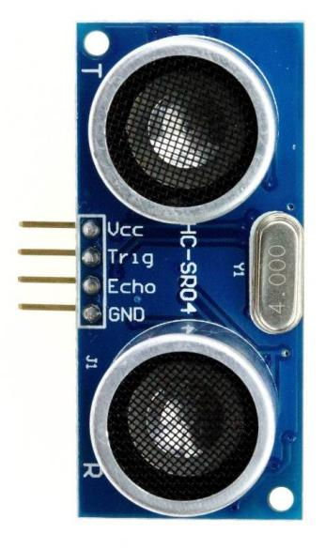

1. A water pump - you can get from here

## <http://www.amazon.in/ZOLTA-Khaitan-Submersible-Aquarium-Fountains/dp/B0195F4YRK/ref=sr_1_1?ie=UTF8&qid=1473598368&sr=8-1&keywords=submersible+water+pump>

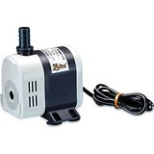

1. water tube (compatible with your pump)
2. Jumper cables, wires
3. A water reservoir (bucket)

### Schematic Connection Diagram

## **IOT_water_pump_sensors_bb**

### Connecting the Sensor to GPIO of Raspberry Pi 2

The ultrasound sensor consists of 4 pins Vcc, Trig, Echo and Gnd.



* 1. Vcc is connected to 5v pin (pin-2)
  2. Trig is connected to output I/O pin of Rpi (pin 16)
  3. Echo is connected to input I/O pin of Rpi (pin 18)
  4. Gnd is connected to Gnd pin of Rpi (pin 6)

## **Below schematic of the GPIO Pins. The 3rd one is for Pi2**

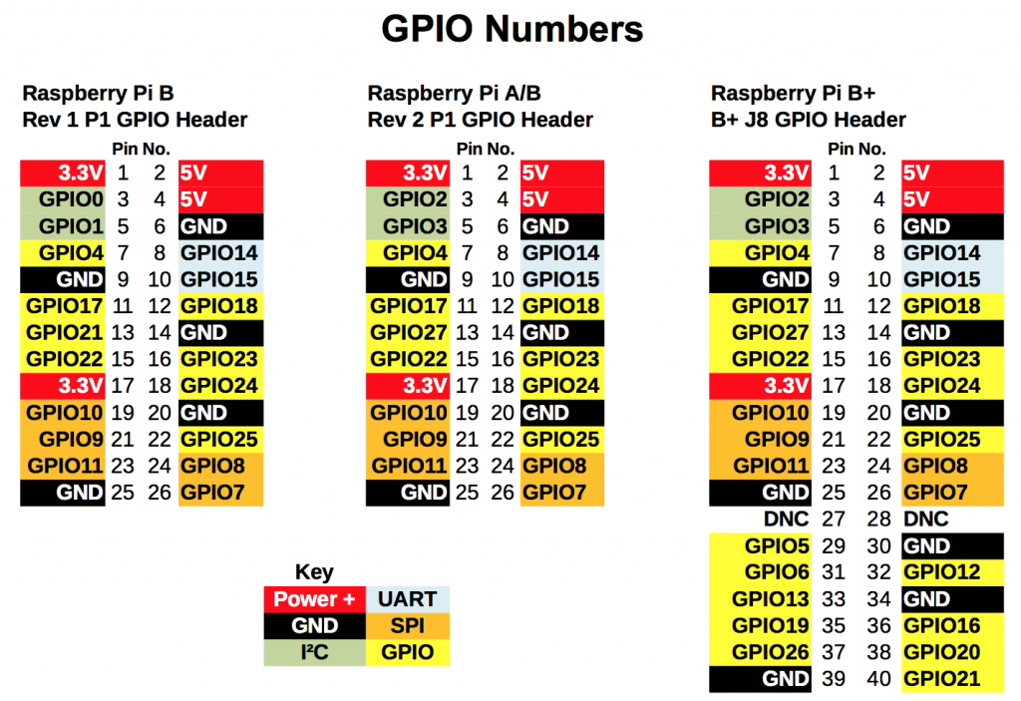

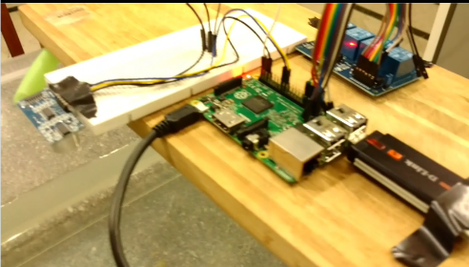

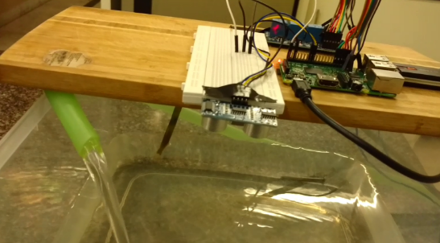

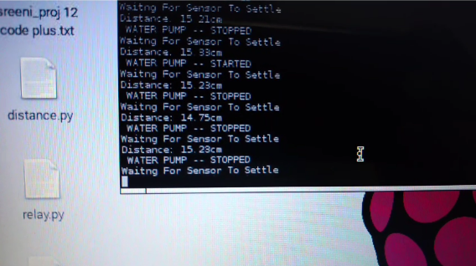

### Pushetta channel creation

1. Log on to [www.pushetta.com](http://www.pushetta.com/); create an account and login
2. In channels Tab click on “Add a Channel”
3. Create a new channel by providing following details
   1. Channel name
   2. Description
   3. Kind (public/private)
4. Navigate to channel tab click on the channel name just created
5. Copy the Advertise url.

For eg: **<http://pushetta.com/subs/dispatch/TEST>\_NAME/**

1. Navigate to Dashboard tab and copy the API Key